LUMEN™ EASE Customer Impact Bulletin

Date of Notification: 6/4/2021
Subject: Archival of existing LV3 ASR/LSR activity
System(s) Impacted: EASE
Areas Impacted: LV3 ASR/LSR orders
Date Effective: Commencing 6/14/2021

In an effort to provide parity across our ordering systems, LUMEN will be working with Level 3 ASRs/LSRs to begin an archive process. The process will bring the Level 3 platforms into industry compliance by archiving completed orders that are more than 2 years old. This process will occur on a nightly basis during maintenance hours. Users will be able to access the archived orders thru the external archival app in the EASE VFO GUI.

Customers needing to access the archival database can do so thru the External APP, Archival GUI in EASE VFO. Information regarding that process can be found in the EASE USER Guide. A copy of the Archival GUI procedures has been referenced below:

Archival GUI | EASE maintains a 2-year active history of PON (purchase order number) information. Accepted PONs that are older than 2-years will be archived. The archival GUI allows users to search for pons that have been archived in EASE. The archived information will only contain a subset of the original order information.  Step Action  1 From the Order tab, scroll to the External App Data tab. Move your cursor to the right and select the Archival GUI from the displayed menu. 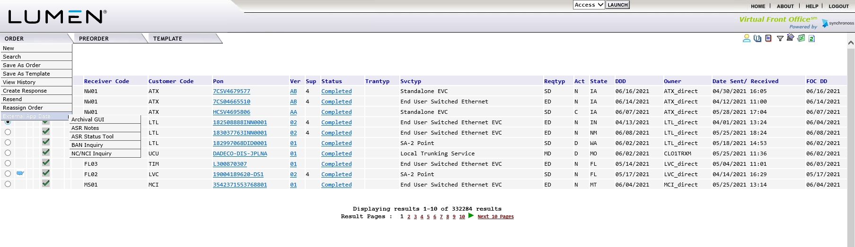  2 The Archival GUI will be displayed. 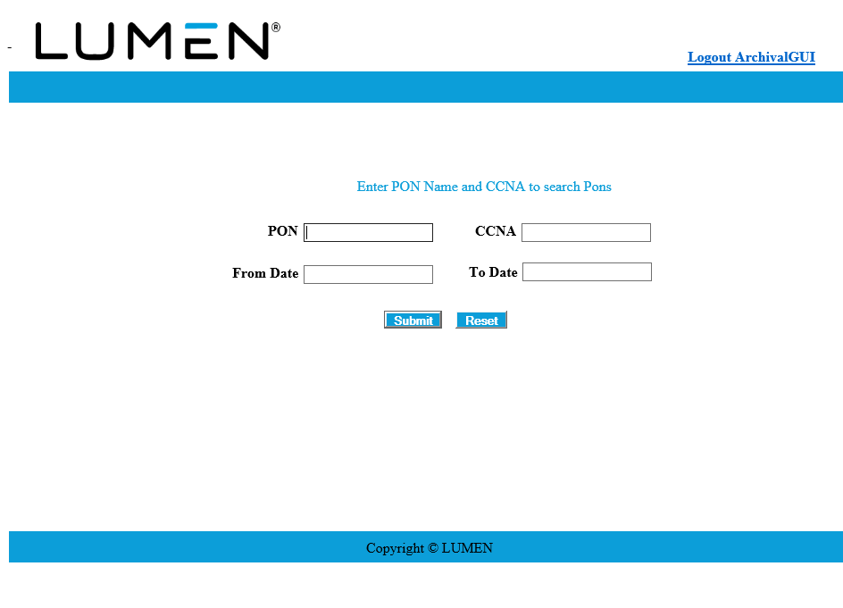  3a To search for a specific pon, enter the PON and CCNA. 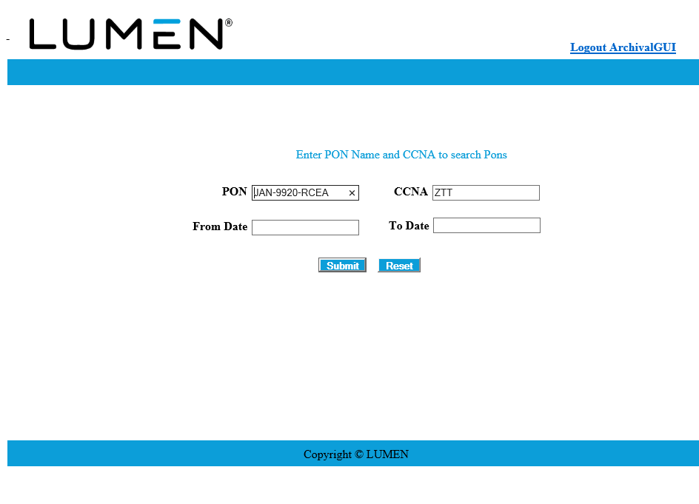  3b To search for a list of PONs, users can use a wildcard option by entering part of the PON information and then using the % key. The system will return all pons that meet the criteria entered. 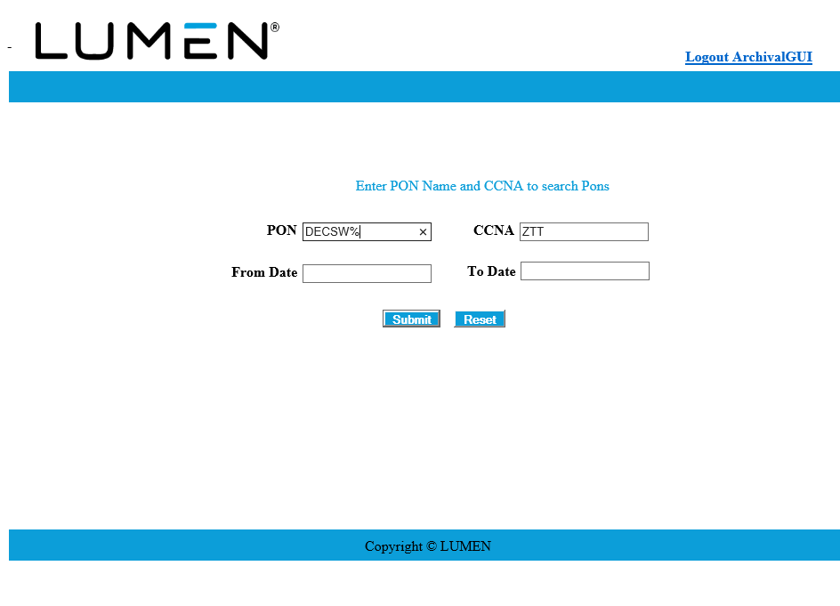  3c To search for a list of PONs within a certain date range, users can enter the From Date and To Date. This can be done by entering the date in the MM/DD/YYYY format or using the pop-up calendar to select a From and To Date. 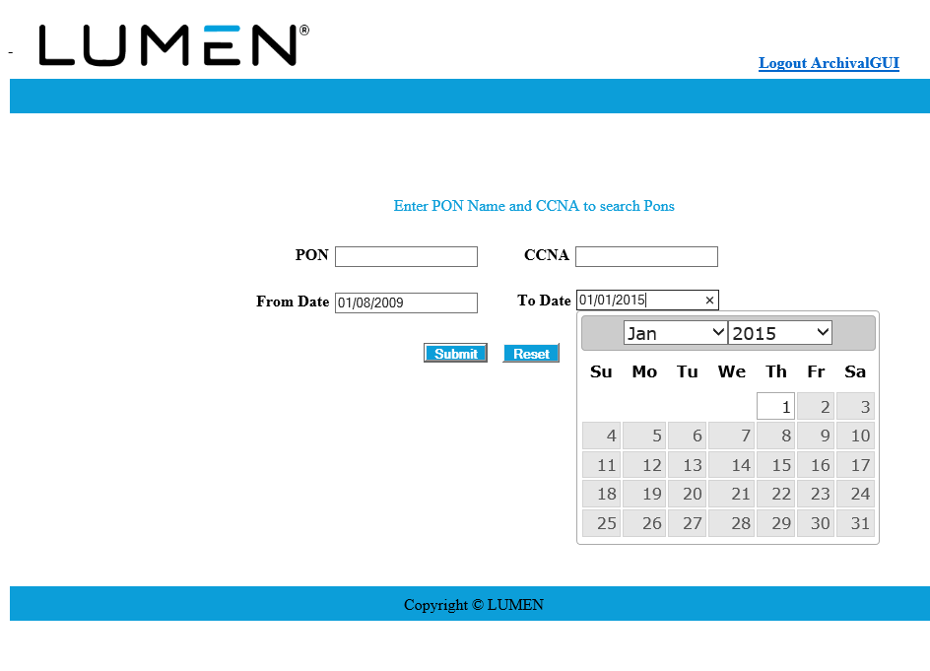 Please Note: this option requires both the From Date and To Date fields to be populated.  4 Click Submit to begin the Archival GUI Search or Reset to remove all field entry.  5 The system will return the archived information based on the criteria entered. 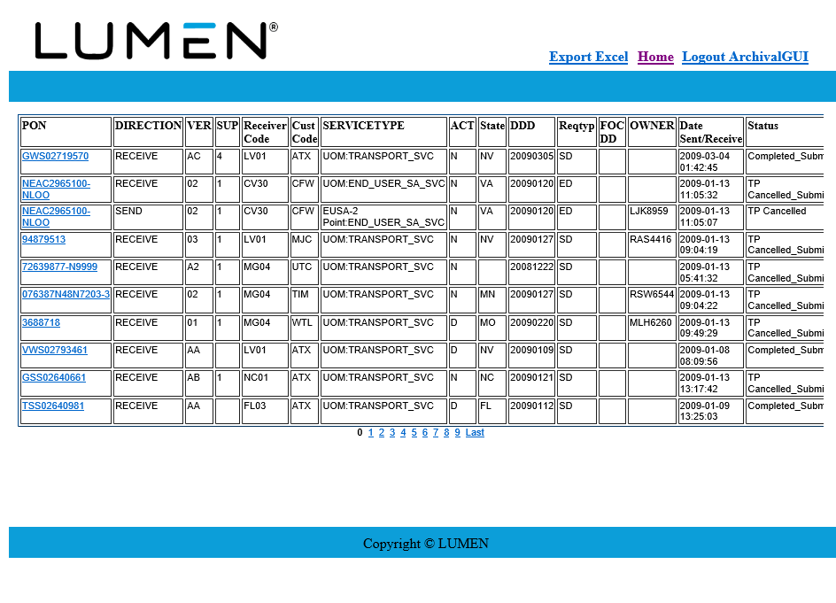 Please Note: users will have the ability to click on additional page numbers at the bottom of the screen to view additional results.  6 Users can click on the following hyperlinks within the Archival GUI. in the top right corner: Hyperlink Resulting Action Export Excel Allows the user to export the summarized PON information to Excel for further sorting. Home Allows the user to return to the main Archival GUI screen. Logout ArchivalGUI Allows the user to exit the External App. Users will be asked to close the screen.

